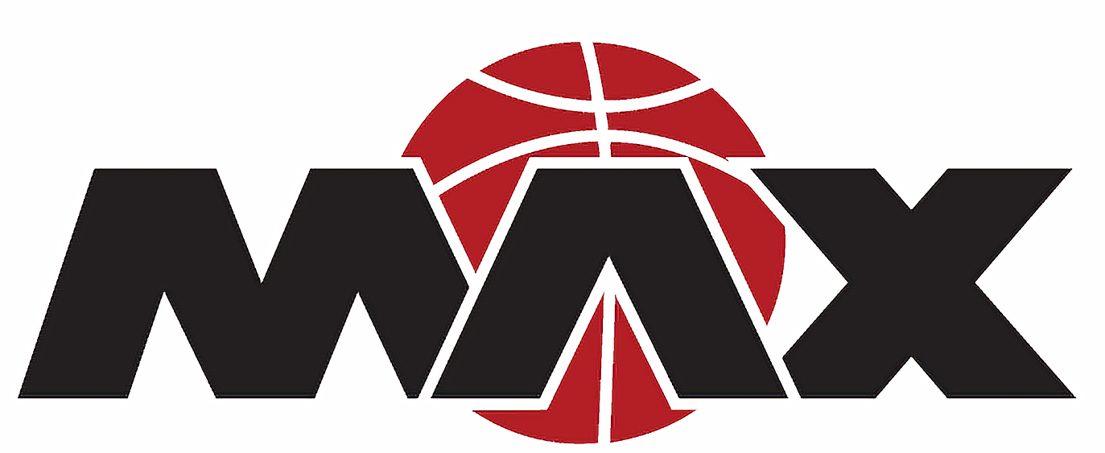
Minnesota MAX Players Code of Conduct
- I will be on time and ready to play for practices and games.
- I will be positive both on and off the court and will not criticize my fellow teammates or opponents.
- I will listen to my coaches and treat them with respect.
- I will speak and act in a respectful way to my coaches, my teammates, my parents, my opponents and the referees. This includes communication using all forms of social media.
- I will demonstrate respect for public property and equipment and will do my best to represent Minnesota MAX while at tournaments and games.
- I will not question or speak inappropriately to the referees. Only a coach may question a referee’s call.
- I will be a team player and have fun!!

Violations of the player code of conduct will result in disciplinary action. Coaches will have the authority to take disciplinary action up to a one game suspension and the parent will be notified of the infraction. I have read and agree to the Player’s Codes of Conduct. My signature indicates my willingness to positively participate to the best of my ability while abiding by the highest level of sportsmanship and conduct in order to encourage a positive and enjoyable experience for all. I understand the consequences if I fail to comply.

