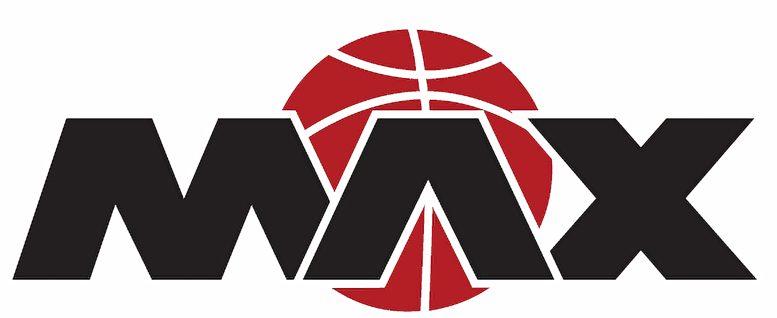
Minnesota MAX Policies
- Team Fees
  - Fees for the 2023 season are as follows:
    - 4th-5th Grade - $425
    - 6th-8th Grade - $525
    - 9th -11th grade - $625
    - All Season Fees must be paid prior to or at the first practice.
    - Fees can be paid by cash, check (made out to Jessica Evers/MN Max Basketball) or Venmo (@Jessica-Evers-9). If using Venmo please include your daughters first and last name and grade level.
    - The fees paid are used for the following: gym space rental, coaches salary, tournament registrations, insurance, etc.
  - A “uniform deposit” in the amount of $100 will also be collected with the team fee. This check will be destroyed once the uniform is returned within 2 weeks of the last tournament. If a uniform is not returned the check will be cashed.
  - No refunds will be given for any reason.
- Uniforms/Apparel
  - Each player will be issued a Minnesota MAX uniform to wear through the season.
  - All uniforms must be returned within 2 weeks of the final tournament.
  - Please take good care of your uniform!!
  - Minnesota MAX will provide each player with a shooting shirt to keep.
  - Additional apparel will be available to purchase via an online store. Info will be sent out as soon as the store is available.
- Practices/Tournaments/ Schedules
  - Practice schedules and tournament schedules will be posted on the Team Snap App.
  - Please try your best to be on time for practices and games! Precious time is lost when a player is late.
  - If you will not be able to attend a practice or a game, please inform your coach right away.
  - Tournament schedules will be posted as soon as they are available. Please remember, we are at the mercy of the tournament directors when it comes to these things!
  - This is a competitive team and equal playing time is not guaranteed at any time.

